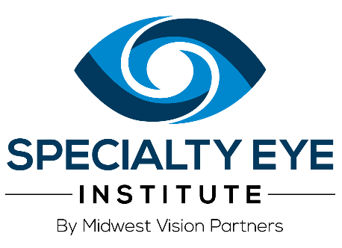
Dear Esteemed Colleague,

We value our partnership in the shared care of our patients. We also want to assure clarity in our clinical roles and financial relationships with patients opting for refractive surgery co-management (LASIK or PRK). Effective August 1,2023 Specialty Eye Institute will be responsible for setting and collecting our fees for the testing and surgery. In turn, our partner co-managing doctors will be responsible for setting and collecting their fees (fair market value) from patients for the pre-operative and/or post-operative services.

We know patients have a choice when it comes to eye care, and we are looking forward to continuing to work with you on providing excellent service. We are dedicated to making this go smoothly for you and your patients.

Should you have any questions, please contact your dedicated liaison Terri Jess by phone at (269) 217-5102 or email at tjess@midwestvision.com or Ericka Baer by phone at (517) 749-1712 or email at ebaer@midwestvision.com. They will be visiting your offices over the next few weeks. Our Midwest Vision Partner’s VP of Physician Engagement, Katie Greiner OD, is also available to set up a time to meet with you by emailing her at kgreiner@midwestvision.com.

Sincerely,
The Specialty Eye Institute Team

If patient stays in house with SEI for pre-op/SX/post-op - $2475/eye (LASIK/PRK)
If patient does pre-op/SX with SEI - we will deduct $190/eye
If patient does SX/post-op with SEI - we will deduct $190/eye
If patient does only SX with SEI - we will deduct $380/eye
We will still honor our current discounts.

Vision insurance - $200/eye
first responders/military/teacher - $250/eye
Current promotion - $300/eye

© 2024 Specialty Eye Institute. All rights reserved.
Suite 3110, 500 West Madison St, Chicago, IL 60661
Unsubscribe

